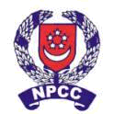

HAI SING CATHOLIC SCHOOL
NATIONAL POLICE CADET CORPS
We share the same blood – BLUE! *

Pressure Lamp

Introduction
A source of light used in outdoor activities. It is preferred over the hurricane lamp as it produces a stronger source of light. The main characteristic of the pressure lamp is that it uses pressure in addition to fuel.
How the Pressure Lamp works
The methylated spirit in the spirit dish is ignited and this heats up the vaporization tube. Air is pumped into the kerosene container and this pressure formed will force the kerosene up the vaporization tube and this is where the liquid kerosene is turned into kerosene vapours. The vapours is mixed with oxygen allowed in through the air inlet and is brought to the mantle. The flame from the spirit dish lights up the mantle.
Safety Precautions
· Do not touch the mantle after it had been burnt.
· Discontinue pumping air into the lamp frame assembly once the pressure pump is tight. This indicates that maximum pressure has been reached.
· Pressure Lamps are not allowed in tents.
· Do not leave Pressure Lamps in the rain and ensure that the hot glass chimney/cylinder does not come into contact with water.
· Make sure the indicator in the pressure gauge does not deflect to the red area.
· Do not use methylated spirit to clean the glass chimney/cylinder although it is easier to remove soot with it.
Pre-lighting Check
· Check that the kerosene container is three quarters full.
· Check that the air screw is tightened.
· Check that the mantle is securely tied to the burner socket.
· Remove the ventilator cap and check that the regulating needle is up.
Maintenance
· Do not use methylated spirit to clean the glass chimney.
· Do not leave the burner socket facing the ground. Either keep it inverted or in the ventilator cap.
· Do not leave the lamp in the rain.

How to fill kerosene
Step 1: Remove the air-gauge (not the pump mechanism)
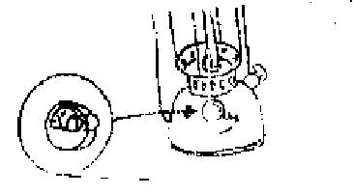
Step 2: Pour kerosene in with an aid of a funnel.
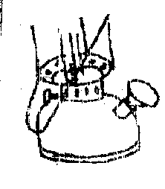
Step 3: Screw back the air-gauge with the rubber washer still inside.
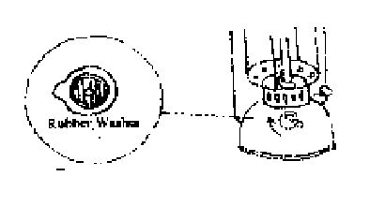

Actual lighting of the lamp

Step 1: Turn the regulator pointing upwards (filter needle must be up).

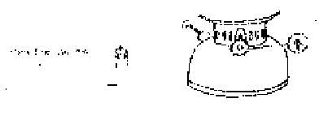
Step 2: Fill the spirit dish with methylated spirit through a small opening.

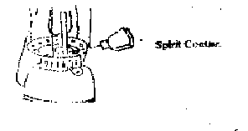
Step 3: Light the methylated spirit. The spirit will burn the mantle. Sufficient heat
will glow the mantle.

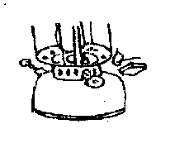
Step 4: Pump in air between 50 to 60 strokes at the same time regulating till the
mantle is at its brightest.

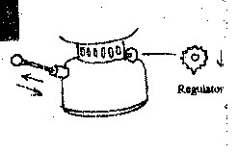

Increase the pressure from time to time when the mantle is dimmed. To extinguish the lamp, just loosen the airscrew.

Procedures of lighting a Pressure Lamp
Type of Mantle
Step 1: Unscrew nuts by the side of the ventilator cap.

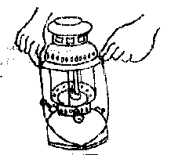

Step 2: Remove the ventilator cap and the mixer flame assembly.
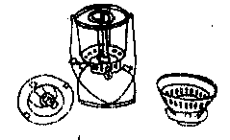

Step 3: Tie the mantle to the burner socket. (Ensure that the burner socket is attached firmly to the mixer flame assembly.)
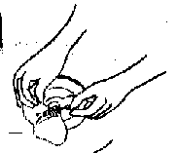

Step 4: Replace the mixer flame assembly. (Taken note of the nut and filter needle of the vaporization tube.)

Taken from NSSNPCC Website

