

HAI SING CATHOLIC SCHOOL
NATIONAL POLICE CADET CORPS
We share the same blood – BLUE! *

Round Lashing
Used for joining 2 poles together.
Used in the construction of flagpoles.

Method:
Start with a clove hitch around the both spars.
Continue with nine or more turns, tightening the rope at every half-turn.
End the lashing with a clove hitch.

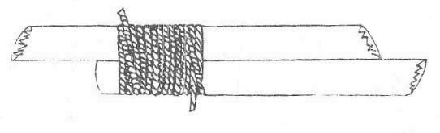
Shear Lashing
It is made near the tip of a pair of parallel poles, so that this pair can be opened out to form a pair of "scissors legs", known as shear legs.

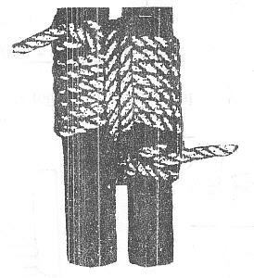

Square Lashing
Used for securing 2 spars touching and crossing each other at any angle.

Method:
Start with a clove hitch on the upright spar. Carry the end in front of the horizontal, behind the upright and down in front of the horizontal.

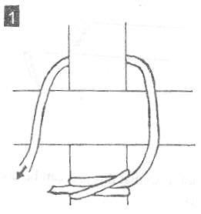
Continue this way keeping inside previous turns on the upright and outside previous turns on the horizontal.

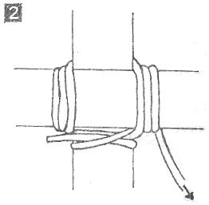
After three to five turns as described above, conclude with 2 to 3 frapping turns.
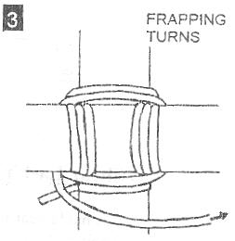

Dispose the end by tying a clove hitch on the other spar.

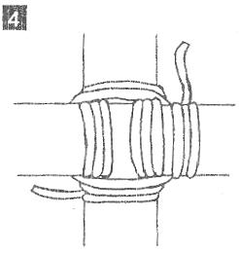

Diagonal Lashing
Used for securing 2 spars crossing each other but standing apart at an acute angle to each other.

Method:
Start with a timber hitch across both spars. Take 3 or more turns in 1 direction.

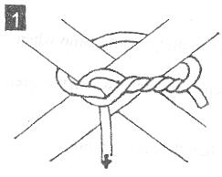
Continue with the same number of turns in the opposite direction.

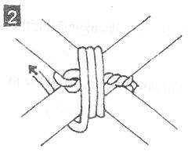
Tighten with frapping turns.

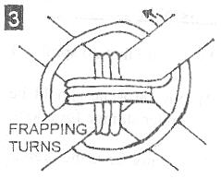

Dispose the end by tying a clove hitch on the nearer spar.

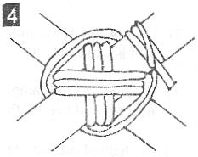

Gyn Lashing or Figure-of-Eight Lashing

Used for lashing 3 poles together to make a tripod

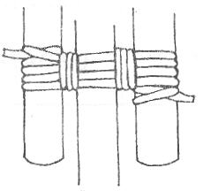
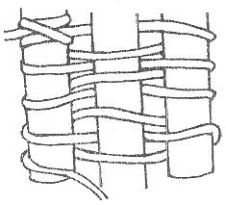
Used for making rafts.

