

HAI SING CATHOLIC SCHOOL
NATIONAL POLICE CADET CORPS
We share the same blood – BLUE! *

Introduction
In the building of gadgets, the most important factor is the design. After you have designed a gadget, carrying out the plan will not pose any difficulty. Try to be original and make sure that your design is practical. The best way is to make a small model first. Making camp furniture can add new dimensions to camp fun especially for youngsters who want to do something constructive. Use proper and suitable lashings to build the gadgets. Following up are some examples of gadgets, which you may modify or improve on.

Broom
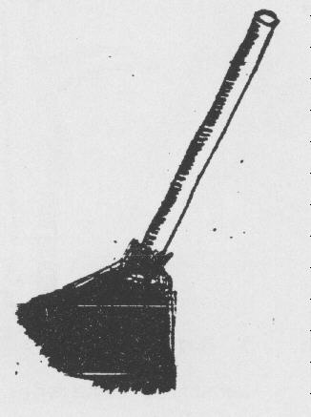
Materials required:
Coconut leaves
Twine
Long pole
Method:
Remove the coconut leaves from the main stem. Bundle them together and tie one end with a clove hitch. Sharpen one end of the pole and insert it into the bundle.

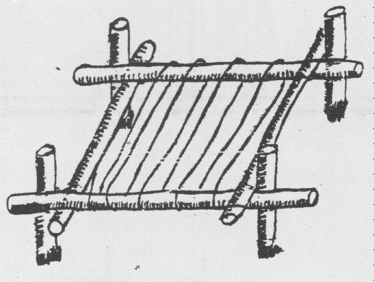
Bed
Materials required:
4 long poles
4 short poles
Twine
Method:
Use square lashing to secure the 4 long poles so that a rectangle is formed as the base. Use square lashing to join a short pole to each of the 4 corners to form the supports. Tie the twine to the frame with a clove hitch, and wrap the twine across the frame. End off with a clove hitch.

3. Table & Bench

Materials required:
12 long poles
12 short poles
Twine
Method:
Using the long poles, make 2 tripods. Tie 2 long poles lengthwise across the tripods. Using the long poles, construct the seats as in the drawing. Tie the table top by using shear lashing to lash the short poles together. Except for the tabletop, square lashings are used for all other joints

